Scatter Plots and Trend Lines
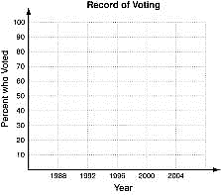
Graph a scatter plot using the given data.

1.

The table shows the percent of people ages 18
–
24

who reported they voted in the presidential elections.

Graph a scatter plot using the given data.

Year

1988

1992

199
6

2000

2004

% of 18
-

24
year olds

36

43

32

32

42

Write positive, negative, or none to describe the correlation illustrated by each scatter plot.
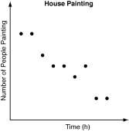
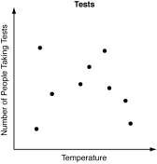
2.

________________________________
________

________________________________
________

Number of sandwiches | 1 | 2 | 4 | 6 | 7
Minutes | 3 | 4 | 5 | 6 | 7
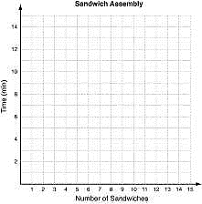
3. Neal kept track of the number of minutes it took him to assemble sandwiches at his restaurant. The information is in the table below.
- Graph a scatter plot of the data.
- Draw a trend line.
- Describe the correlation as either positive or negative.
________________________________________
- Based on the trend line you drew, predict the amount of time it will take Neal to assemble 12 sandwiches.
________________________________________

Scatter Plots and Trend Lines

4. Fawn is trying to improve her reading skills by taking a speed- reading class. She is measuring how many words per minute (wpm) she can read after each week of the class.
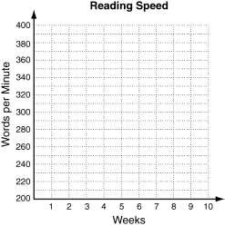
a. Graph a scatter plot using the given data
Weeks | 1 | 2 | 3 | 4 | 5
wpm | 220 | 230 | 260 | 260 | 280

b. Describe the correlation illustrated by the scatter plot.

c. Draw a trend line and use it to predict the number of words per minute that Fawn will read after 8 weeks of this class.
________________________________________
d. Fawn is paying for this class each week out of her savings account. Identify the correlation between the number of classes and Fawn’s account balance.
________________________________________ ________________________________________

Choose the scatter plot that best represents the described relationship.
a. the distance a person runs and how physically tired that person is
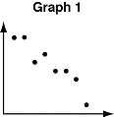
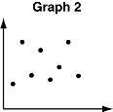
- Graph 1 C Graph 3
- Graph 2 D Graph 4
b. the price of a new car and the number of hours in a day
  - Graph 1 H Graph 3
  - Graph 2 J Graph 4
c. a person’s age and the amount of broccoli the person eats
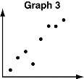
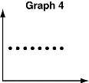
  - Graph 1 C Graph 3
  - Graph 2 D Graph 4
d. the number of cats in a barn and the number of mice in that barn
  - Graph 1 H Graph 3
  - Graph 2 J Graph 4

